**How to create ec2 instance and connect through putty using the private key .ppk**

**First step login to aws console and click on launch instance**

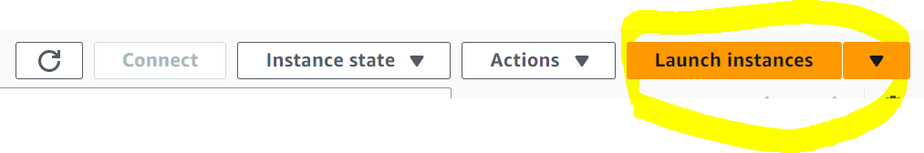

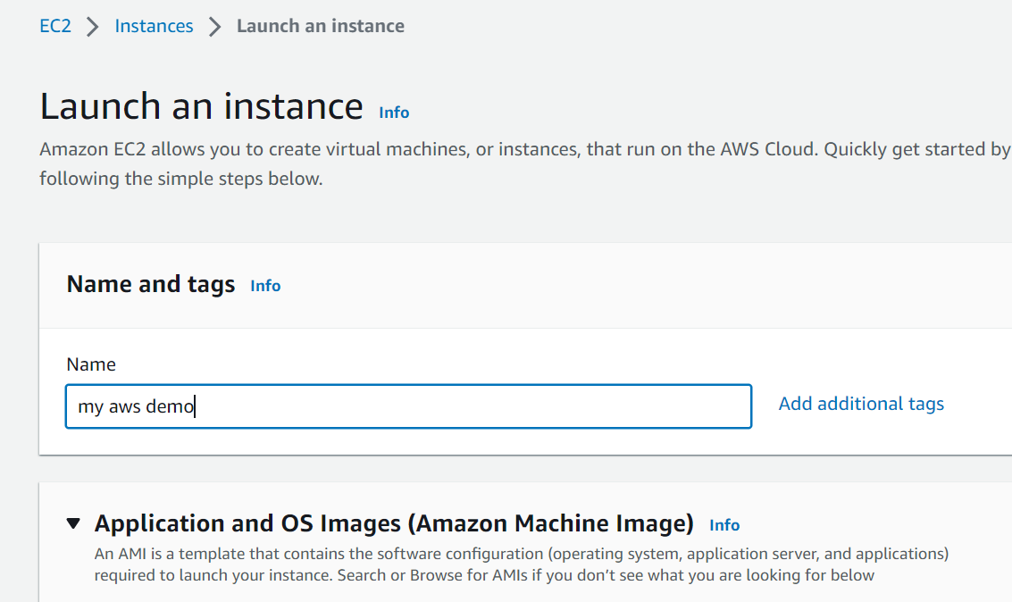

**I will select Ubuntu where as it has multiple OS that can be selected**

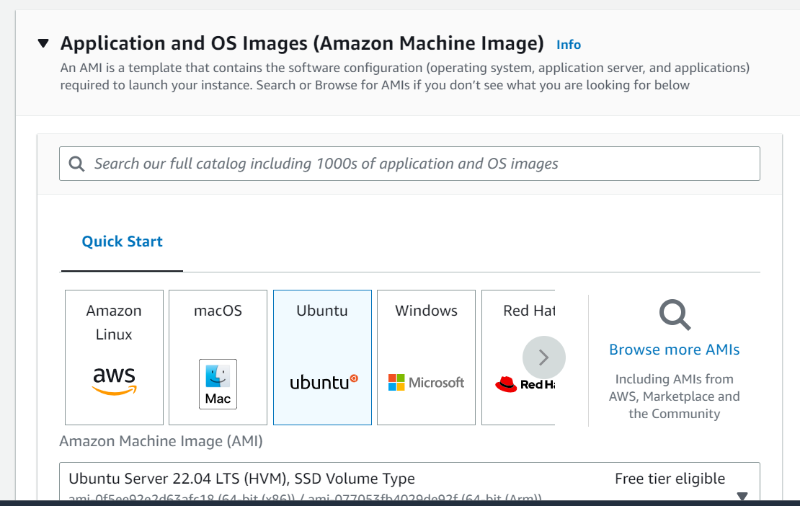**Create key pair to connect to the instance,**

**Provide name to key pair**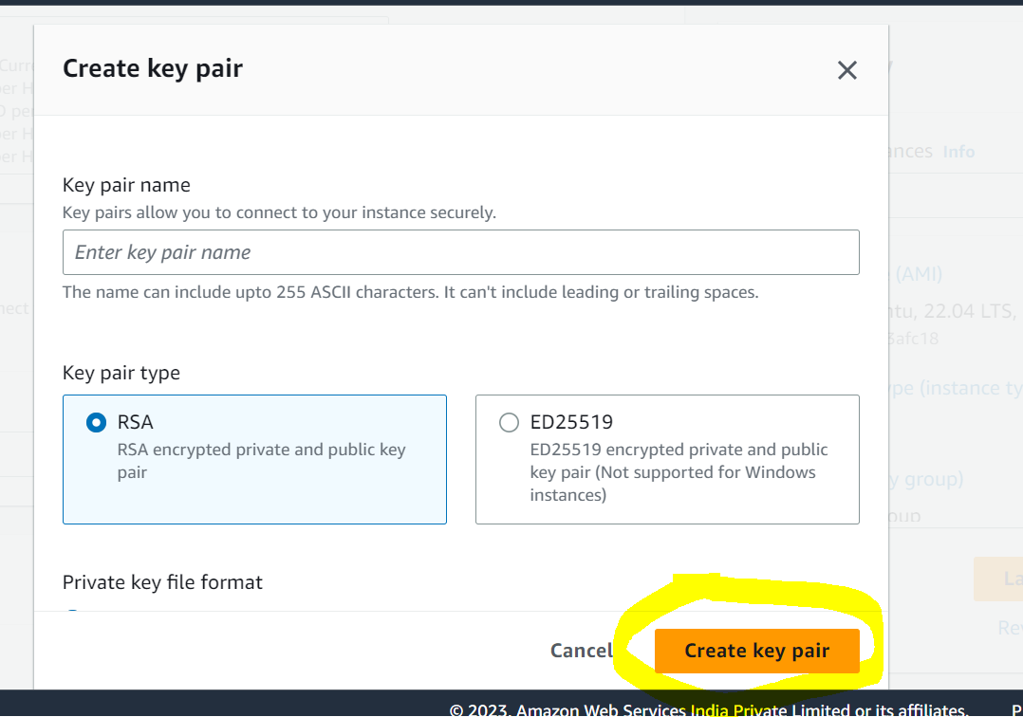

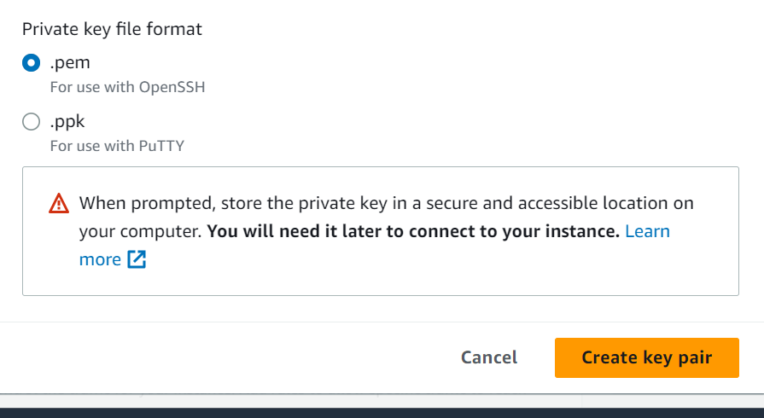

**Perform network setting or go with default network setting**

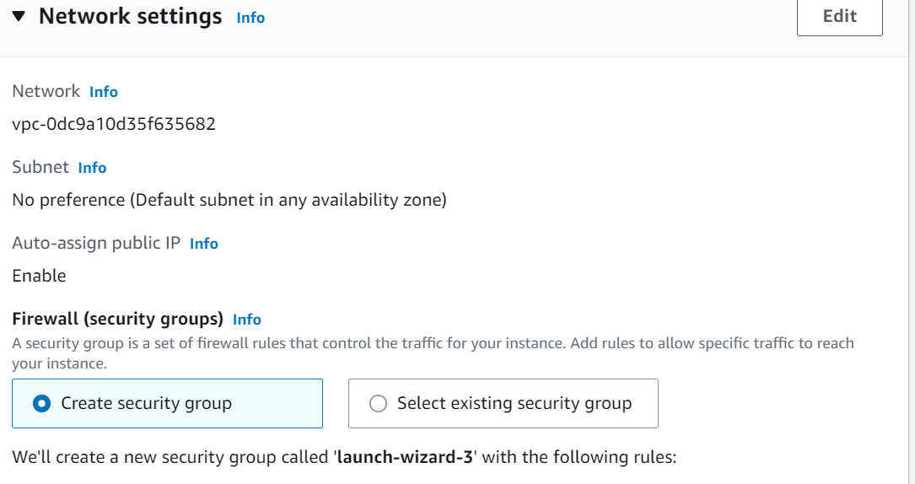

**Under Storage (Volumes)**

**======================**

**I will select option as Encrypted in order to avoid later audit or security requirements**

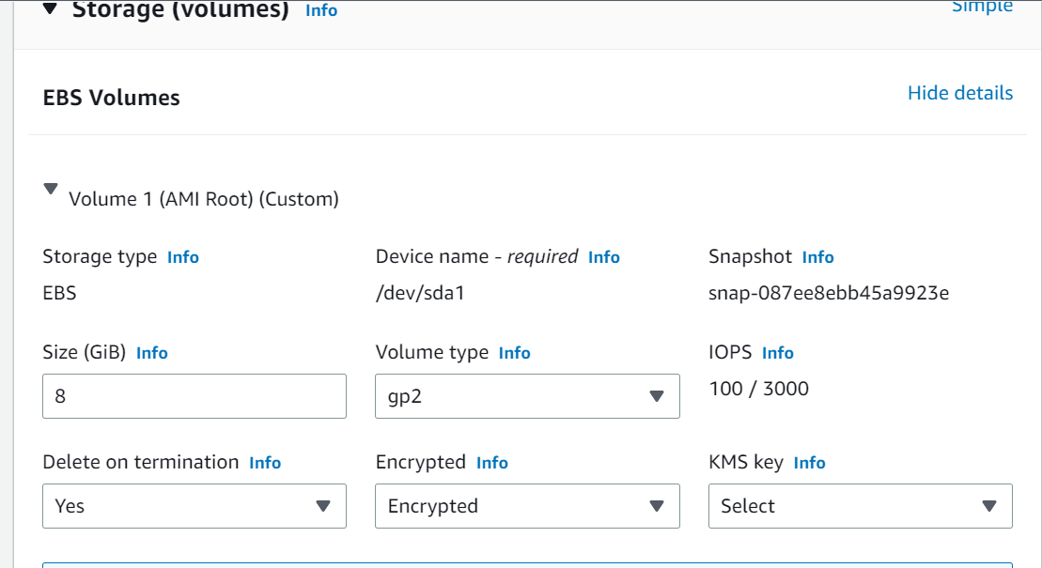

**Then click on instance launch.**